The first thing you need to do is set up the DHCP server. Download ([link here](http://tftpd32.jounin.net/)) Tftpd32 standard edition or Tftpd64 standard edition, if you have a 32 bit OS download Tftpd32, if you have a 64 bit OS download Tftpd64. If you don’t know what type of OS you have get the 32 bit one.

1. Run the Tftpd program and press settings  
   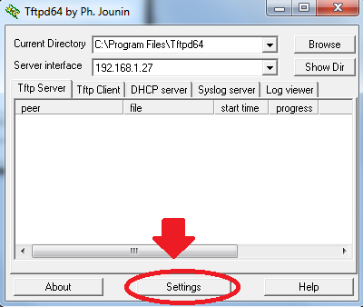
2. Select the DHCP tab and adjust the settings to the ones show in the picture and below. Then click OK.   
   IP pool starting address: 192.168.0.10  
   Size of Pool: 50  
   Mask: 255.255.255.0  
   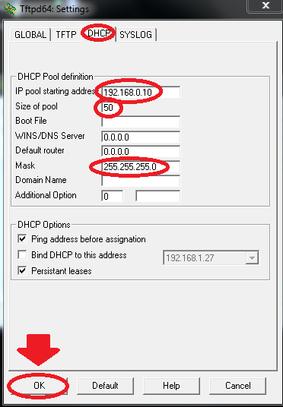
   1. The DHCP server is now set up, make sure you leave the Tftpd program on.
3. Now you set a static IP for the server. Start by opening the Control Panel.  
   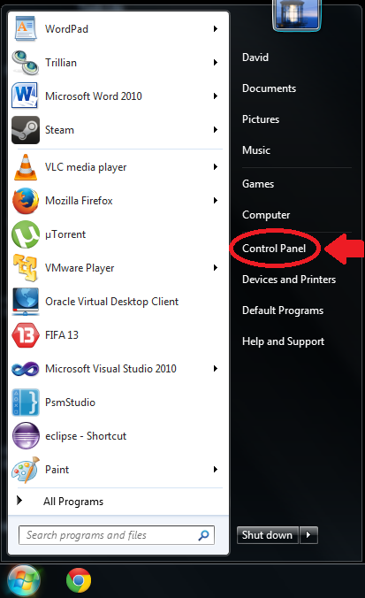
4. Under “Network and Internet”, click “View network status and tasks.” This will open the Network and Sharing Center.  
   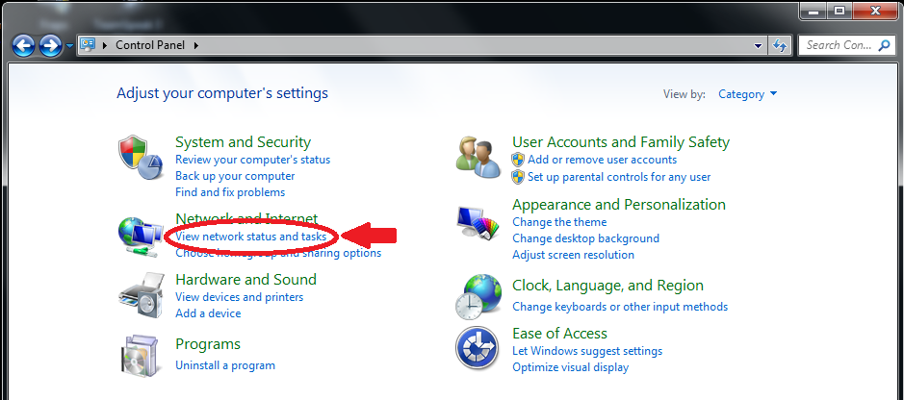
5. Then click ‘Change adapter settings”  
   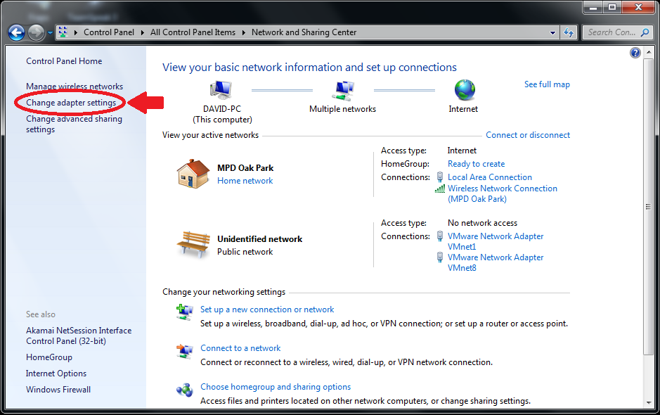
6. Find the wireless network card you’re going to use, right click it and select “Properties”  
   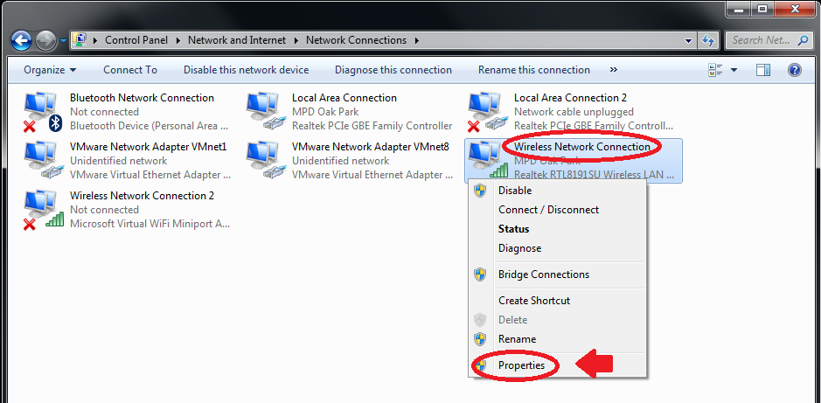
7. Select “Internet Protocol Version 4 (TCP/IPv4) and the click “Properties”  
   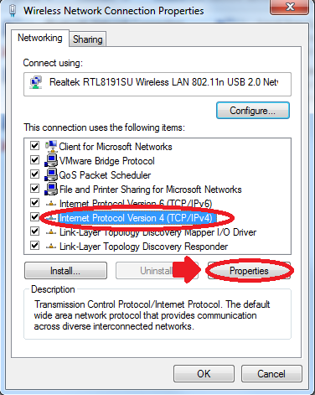
8. Select the “Alternate Configuration” tab  
   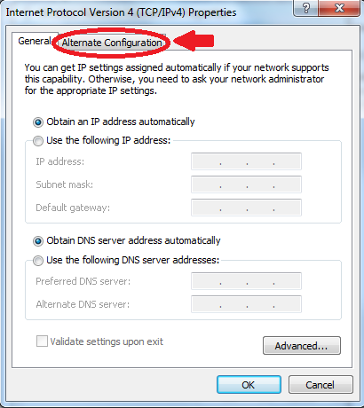
9. Adjust the settings to match the picture. Then click OK.  
   Select User Configured  
   IP address: 192.168.0.1  
   Subnet mask: 255.255.255.0  
   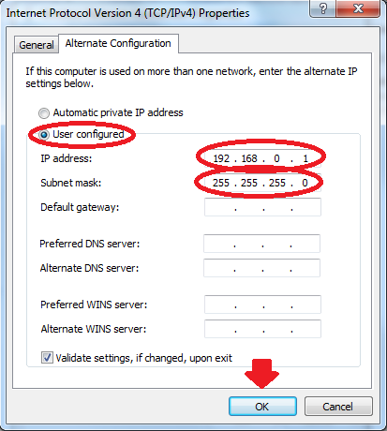
   1. The server will now have a static IP and it’s time to set up the ad Hoc server.
10. Follow Steps 3 and 4 to get back to the Network and Sharing Center. Then click “Manage wireless networks”  
    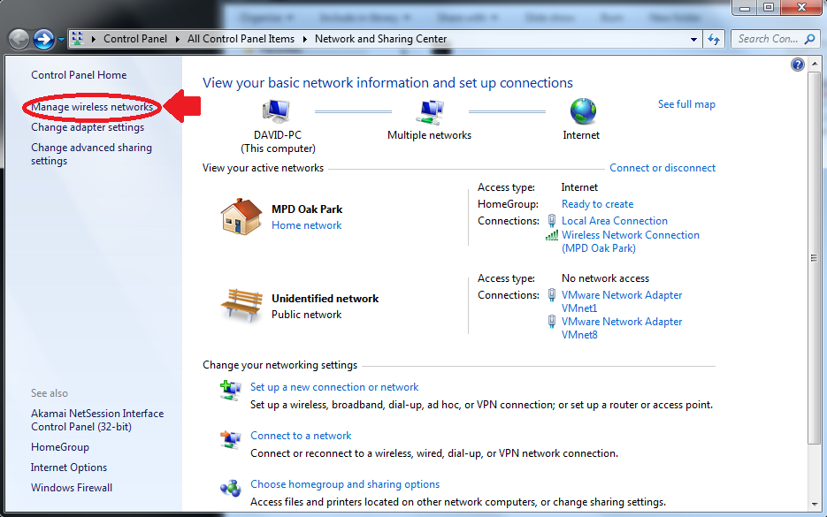
11. Click “Add”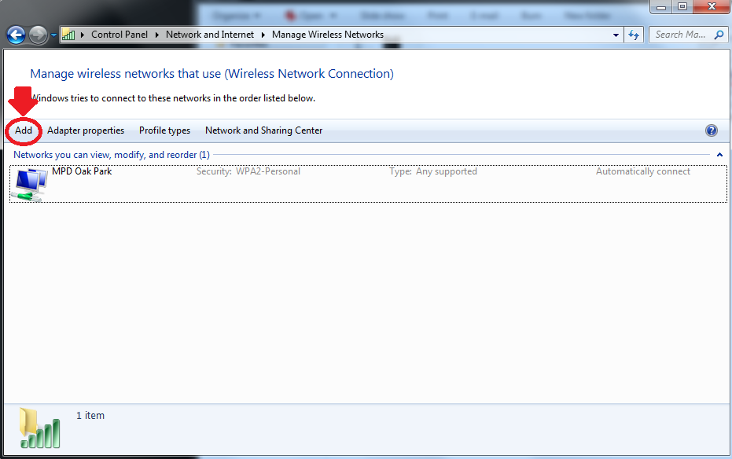
12. Select “Create an ad hoc network”  
    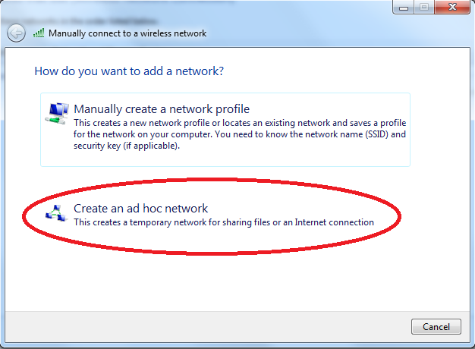
13. Name the network femr-adHoc, use WEP security, and set the password to 12345. (You can name the network whatever you want, use WPA security, and use any password it allows. The ones provided are merely a suggestion.)  
    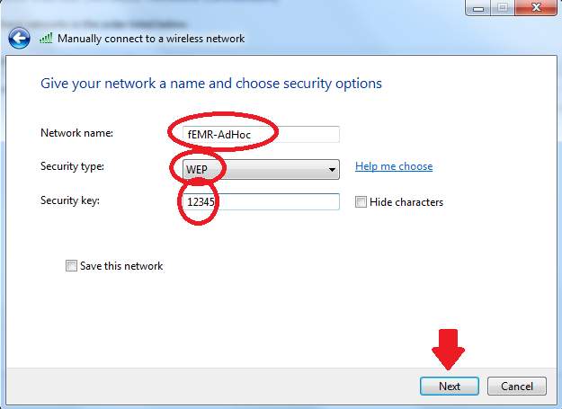
14. The ad Hoc network is now set up with a static IP and DHCP server, have someone connect to the server and wait for them to be assigned an IP. Clients can access the server by typing 192.168.0.1:9000 (if that doesn’t work just type 192.168.0.1) in to their URL.